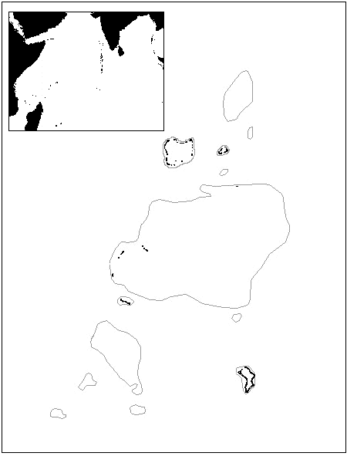

Chagos

Maldives

Laccadives

Peros Banhos

Salomon
Blenheim

Nelson
Great Chagos Bank
Three Brothers

Eagle Is

Danger Is
Speakers Bank

Pitt Bank
Diego Garcia

Egmont

6 S

7 S

71 E

72 E

50 km

Victory Bank

